

Attendance Monitoring System

**project REPORT**

Term I (Year 2)

*Submitted by*

***TEAM SIGMA***

**Anne Asrita E0121057**

**Ruthvika Muchala E0121036**

**Sasank Chowdary.K E0121013**

**Sivane Senthil E0121027**

**COMPUTER SCIENCE AND ENGINEERING**

**(AIML)**

**Sri Ramachandra Engineering and Technology**

Sri Ramachandra Institute of Higher Education and Research, Porur, Chennai -600116

**OCTOBER, 2022**

**Table of Contents**

**Title** **Page**

1.Introduction 3

2. Objective 3

3.Problem statement 4

4.Materials and methodology 4

4.1 RFID 4

4.2 Attendance monitoring system with RFID 4

5.Tools and Technologies 5

6.Code 9

7.References 13

8.Conclusions 13

**1.Introduction:**

Attendance needs to be taken at various places including colleges, schools for students, and industries. Attendance is mainly required for the login logout time of employees. Radio Frequency Identification (RFID) based attendance management systems can be used in any college or university or company. The main objective of RFID based Attendance System project is to take the attendance of students or employees. The microcontroller does the task of storing the attendance of the respective person in the Microcontroller memory.

**2.Objective:**

Attendance monitoring system using RFID technology and with the application of Internet of Things (IoT) and cloud technology will be obtained a presence system that can run and monitored in real time, so that all parties who need information such as lecturers, parents, and energy the administration can immediately find out if there are students who skip classroom, it can immediately be prevented so that the next meeting does not ditch again.

The existing attendance system is manual and it is taken on paper and it consumes a lot of time. As we are aware that many traditional Attendance systems use an attendance register to note down attendance. It has less accuracy. Also, the administrative person needs to maintain the attendance papers/sheets.

**3.Problem statement:**

Creating a device that is easy-to-use and economical for staff to record attendance automatically.

**4.Materials and methodology:**

**4.1 Radio-frequency identification (RFID)**

RFID has grown rapidly in recent decades along with the demand from modern industry where data accuracy is required and efficiency improvements of a system, the supporting components of this electronic equipment are RFID reader and RFID Tags, where many kinds of tags have been manufactured according to industry needs. This technology has been applied to various sectors such as industry , airports , attendance monitoring systems , and with the use of IoT will be able to make this system more optimal.

**4.2 Attendance monitoring system with RFID**

In this system each student has an RFID Tag to do presence, student put RFID Tag near RFID Reader, then ID result from RFID reader will be sent to microcontroller and compare it with the student data stored in memory, memory serves to store the data of the student's name of the course, if the data ID is a lecture participant then the student's name will be displayed on the LCD Display as well if the student data is not listed it will be informed through LCD Display that the student unregistered.

**5.Tools and Technologies:**

**Raspberry pi4:**

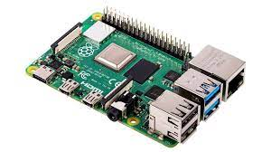

The Raspberry Pi 4 is the best Raspberry Pi, the best single-board computer and one of the best values you can get in tech.While most adult user would not want to replace their PCs with one, the Raspberry Pi 4 is powerful enough to use a desktop computer in a pinch.

**Power supply:**

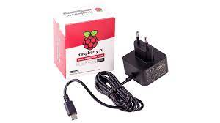

We used 12.5 W Micro USB Power supply which is the latest recommended power supply for all micro USB-powered Raspberry Pi computers.

**Micro SD card:**

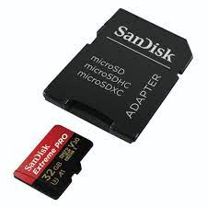

The micro SD card is a key part of Raspberry Pi ; it provides the initial storage for the Operating System and files.Storage can be extended through many types of USB connected peripherals.

**RFID reader:**

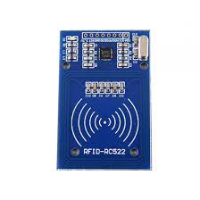

Radio Frequency Identification(RFID) refers to a wireless system compromise of two components: tags and readers. The reader is a device that has one or more antennas that emit radio waves and receive signals back from the RFID tag.

**Bread board:**

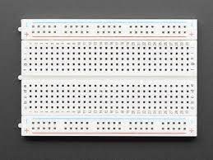

A breadboard is used for building temporary circuits. It is useful to designers because it allows components to be removed and replaced easily.It is useful to the person who wants to build a circuit to demonstrate its action,reuse the components in another circuit.

**LCD:**

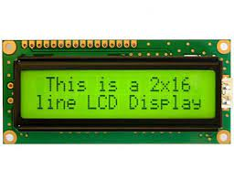

LCD (Liquid Crystal Display) is a type of flat panel display which uses liquid crystals in its primary form of operation. LEDs have a large and varying set of use cases for consumers and businesses, as they can be commonly found in smartphones, televisions, computer monitors and instrument panels.

**Potentiometer:**

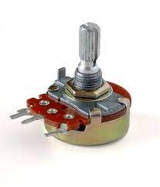

A potentiometer is a three terminal resistor with a sliding or rotating contact that forms an adjustable voltage divider.If only two terminals are used, one end and the wiper, it acts as a variable resistor or rheostat.

**Jumper wires:**

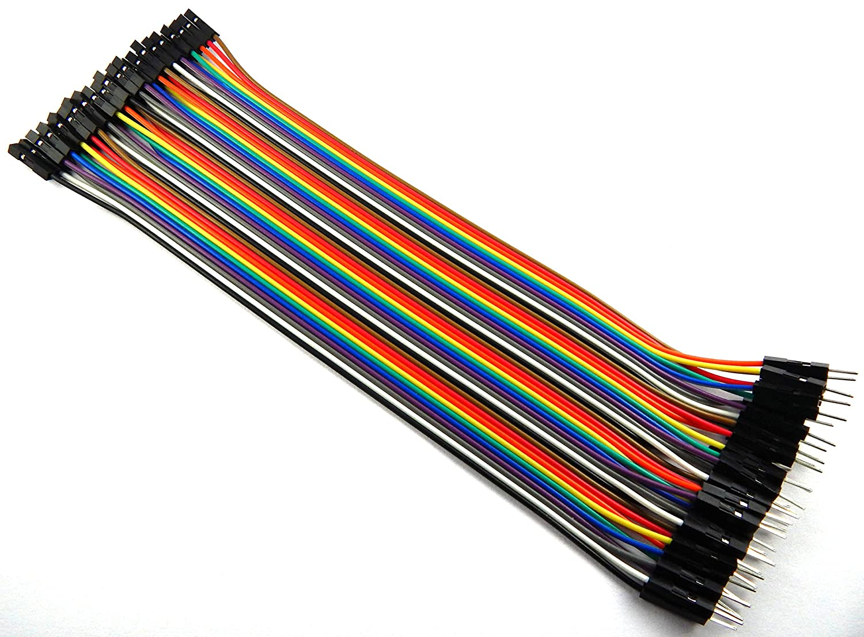

8 pieces of Male to Male Breadboard wires

8 pieces of Male to Male Breadboard wires

**Ethernet cable:**

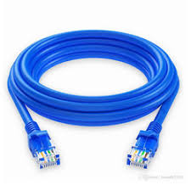

An Ethernet cable is a very popular type of network cable which is used for wired networks (a network type which connects devices to the Internet or other networks using cables). They are used to connect devices located on local area networks (LANs), such as routers, PCs and switches.

**6.Code:**

**Read.py**

import RPi.GPIO as GPIO

from mfrc522 import SimpleMFRC522

reader = SimpleMFRC522()

try:

id, text = reader.read()

print(id)

print(text)

finally:

GPIO.cleanup()

**Save_user.py**

import time

import RPi.GPIO as GPIO

from mfrc522 import SimpleMFRC522

import mysql.connector

import Adafruit_CharLCD as LCD

db = mysql.connector.connect(

host=&quot;localhost&quot;,

user=&quot;attendanceadmin&quot;,

passwd=&quot;pimylifeup&quot;,

database=&quot;attendancesystem&quot;

)

cursor = db.cursor()

reader = SimpleMFRC522()

lcd = LCD.Adafruit_CharLCD(4, 24, 23, 17, 18, 22, 16, 2,

4);

try:

while True:

lcd.clear()

lcd.message(&#39;Place Card to\nregister&#39;)

id, text = reader.read()

cursor.execute(&quot;SELECT id FROM users WHERE

rfid_uid=&quot;+str(id))

cursor.fetchone()

if cursor.rowcount &gt;= 1:

lcd.clear()

lcd.message(&quot;Overwrite\nexisting user?&quot;)

overwrite = input(&quot;Overwite (Y/N)? &quot;)

if overwrite[0] == &#39;Y&#39; or overwrite[0] == &#39;y&#39;:

lcd.clear()

lcd.message(&quot;Overwriting user.&quot;)

time.sleep(1)

sql_insert = &quot;UPDATE users SET name = %s WHERE

rfid_uid=%s&quot;

else:

continue;

else:

sql_insert = &quot;INSERT INTO users (name, rfid_uid)

VALUES (%s, %s)&quot;

lcd.clear()

lcd.message(&#39;Enter new name&#39;)

new_name = input(&quot;Name: &quot;)

cursor.execute(sql_insert, (new_name, id))

db.commit()

lcd.clear()

lcd.message(&quot;User &quot; + new_name + &quot;\nSaved&quot;)

time.sleep(2)

finally:

GPIO.cleanup()

Check_attendance.py

import time

import RPi.GPIO as GPIO

from mfrc522 import SimpleMFRC522

import mysql.connector

import Adafruit_CharLCD as LCD

db = mysql.connector.connect(

host=&quot;localhost&quot;,

user=&quot;attendanceadmin&quot;,

passwd=&quot;pimylifeup&quot;,

database=&quot;attendancesystem&quot;

)

cursor = db.cursor()

reader = SimpleMFRC522()

lcd = LCD.Adafruit_CharLCD(4, 24, 23, 17, 18, 22, 16, 2,

4);

try:

while True:

lcd.clear()

lcd.message(&#39;Place Card to\nrecord attendance&#39;)

id, text = reader.read()

cursor.execute(&quot;Select id, name FROM users WHERE

rfid_uid=&quot;+str(id))

result = cursor.fetchone()

lcd.clear()

if cursor.rowcount &gt;= 1:

lcd.message(&quot;Welcome &quot; + result[1])

cursor.execute(&quot;INSERT INTO attendance (user_id)

VALUES (%s)&quot;, (result[0],) )

db.commit()

else:

lcd.message(&quot;User does not exist.&quot;)

time.sleep(2)

finally:

GPIO.cleanup()

**7.References:**

<https://www.matec-conferences.org/articles/matecconf/pdf/2018/23/matecconf_icesti2018_01020.pdf>

<https://www.projectsof8051.com/rfid-based-attendance-management-system/>

<https://www.instructables.com/How-to-Build-Raspberry-Pi-RFID-Attendance-System/>

<https://www.instructables.com/RFID-Based-Attendance-System-Using-Raspberry-Pi/>

**8.Conclusion:**

From the test results can be concluded that the presence by using RFID is faster than the traditional way.